Regional Meeting: Essex  20th October 2021  CloudFM County Ground, New Writtle Street, Chelmsford CM2 0PG | 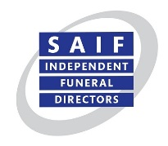
Timings:
6.30 – 7.00 pm Arrive at venue
7.00 pm Meal is served
8.00 pm Meeting starts
9.30 – 9.45 pm Meeting ends

Menu:
Roast chicken served with all the trimmings and rich red wine jus
Or sweet potato, parsnip and butternut squash hot pot topped with sliced new potatoes (v)
Strawberry panna cotta served with a homemade shortbread disc (v).

Booking form

Company name:
Membership status: Funeral director or Associate
Tel. No.
Email address
Delegate Name(s): | Menu choice: Chicken or Hot Pot (V) | Special dietary or disability requirements?

Number of attendees @ £28 pp Total Payment £……………

Complete this form and return to SAIF with payment, which can be made by:

BACS Natwest Bank, Sort Code 60-04-24, Account No: 90098110
Credit Card Please call the SAIF Business Centre

SAIF Business Centre, 3 Bullfields, Sawbridgeworth, Herts, CM21 9DB
Telephone: 01279 726777 Fax 01279 726 300

BACS details

Bank: Natwest Bank

Branch: Camden Town

Sort code: 60 04 24

Account no: 90098110

